**Exercise for Analysis of Algorithms**

* Page no: 477

Ex 11.1 ,11.3, 11.4

* Assume that each of the expressions below gives the processing time T(n) spent by an algorithm for solving a problem of size n. Select the dominant term(s) having the steepest increase in n and specify the lowest Big-Oh complexity of each algorithm.

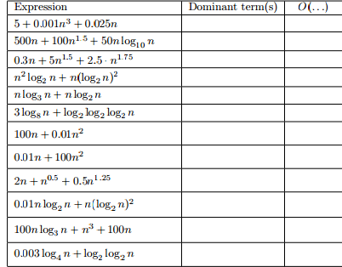

* What is the best asymptotic (big –O) characterization of following function:

F(n) = 25 + 5 n3 log (n) + 26 n2 + 100 n4

* Express the complexity of the following algorithm using the big-O notation.
* 1.

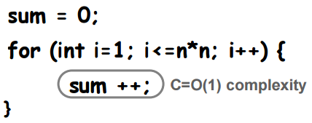

2.

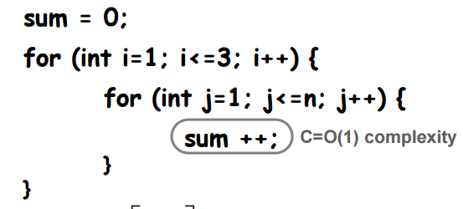

3.

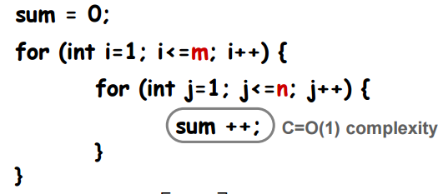

4.

